Asset Tracking Application

Design Document

Prepared by Infotech Enterprises Limited

We delivery tangible cost benefits in implementation and on-going management of next generation networks. We maximise efficiency for operations support to ensure optimum cost-effective network management. We create fit-for-purpose inventory management data to facilitate critical business decision making.

Table of Contents

Table of Contents 2

Section 1 – Introduction 3

Section 2 – ROLES 4

Section 3 – Modules 5

3.1 USER MANAGEMENT 5

3.2 ASSET MANAGEMENT 5

3.3 LOCATION MANAGEMENT 5

Section 4 – User Management 7

4.1 Add User: 7

4.2 Update User: 9

4.3 Delete users: 11

4.4 Change Password: 12

4.5 List of Users 13

Section 5 – Asset Management 14

5.1 Add Asset: 14

5.2 Update Asset: 14

5.3 Delete Asset: 16

5.4 Assign Asset: 17

5.5 Display Assets: 18

5.5.1 Desktop: 18

5.5.2 Laptop: 18

5.5.3 All: 18

5.6 Asset Status: 19

Section 6 – Location Management 20

6.1 Add Location: 20

6.2 Delete Location: 21

6.3 Display Locations: 22

# – Introduction

the description

This document provides guidelines for implementing an asset tracking solution at an organization of any size. It is intended for asset managers that need to keep track of a large number of physical assets. Asset tracking application, allows all information about a company's assets to be stored in one location. This will allow the company to easily find asset information in the database, reduce their lost assets and maintain their equipment better.

This application looks at how an effective asset tracking solution enables organizations to feel secure, knowing that they have a complete inventory without the need for physical or manual checking.

The main aim of the asset tracking system application is to track all the assets of an organisation and keep a record of it in the database. In addition to this it also enables a user to perform some operations on assets. Asset tracking system features an easy to use interface and robust reporting capabilities. This application will drastically cut the time it takes to maintain physical inventories.  
  
This guide shows you how to get started with Asset Tracking System. It explains

• Different modules in the application.

• The basic operations.

• Basic information about the most important tasks you must perform.

# – ROLES

Asset tracking application’s main function is to track all the assets. Tracking of assets has to be performed by an individual. Depending on the application requirements users have been given three roles. The following are the roles provided in the application:

1. ADMINISTRATOR
2. USER
3. GUEST USER

Different privileges have been given to different roles with administrator being the super user who has been given all the privileges. While a user can accesses read only permissions and write permissions for editing his\her profile and guest user can only read all the details but cannot edit or update anything.

There is a facility given to the administrator wherein he can change the role of any user or guest user to administrator. The privileges of different users to different functionalities have been diagrammatically represented in the following page.

# – Modules

Asset tracking system has been divided into modules for ease of usage to the users. Each module has its own set of functionalities and different privileges

Depending upon the core functionalities, application has been divided into three modules. They are

## USER MANAGEMENT

The user management module consists of all the functionalities related to the users like adding, updating and deleting the users along with changing the password and displaying the list of users.

## ASSET MANAGEMENT

Asset management module consists of asset related functionalities like adding of assets, deleting and updating them. The major functionality under this module includes tracking the assets of deleted user, keeping the record of them with a temporary user and assigning those assets back to the new user.

## LOCATION MANAGEMENT

Location management module tracks all the details of locations along with adding new locations and deleting them.

Only the administrator has the privileges to access all the modules and make some changes to it, while the other users have a limited access.

The following table shows the privileges of different users:

|  |  |  |  |  |  |  |  |  |  |  |  |  |  |
| --- | --- | --- | --- | --- | --- | --- | --- | --- | --- | --- | --- | --- | --- |
|  | USER MANAGEMENT | | | | | ASSET MANAGEMENT | | | | | LOCATION MANAGEMENT | | |
| A.U | U.U | D.U | C.P | L.O.U | A.A | U.A | D.A | ASN.A | DP.A | A.L | D.L | DSP.L |
| ADMIN | Y | Y | Y | Y | Y | Y | Y | Y | Y | Y | Y | Y | Y |
| USER | N | Y | N | Y | Y | N | Y | N | N | Y | N | N | Y |
| GUEST USER | N | N | N | N | Y | N | N | N | N | Y | N | N | Y |
|  | | | | | | | | | | | | | |

*A.U - ADD USER, U.U – UPDATE USER, D.U – DELETE USER, C.P – CHANGE PASSWORD, L.O.U – LIST OF USERS

A.A – ADD ASSET, U.A – UPDATE ASSET, D.A – DELETE ASSET, ASN.A – ASSIGN ASSET, DP.A – DISPLAY ASSETS

A.L – ADDLOCATION, D.L – DELETE LOCATION, DSP.L – DISPLAY LOCATIONS

Y - YES, N - NO

# – User Management

Overview

The following are the functionalities that come under user management:

## Add User:

Adding of new users to the inventory is possible using this functionality. But adding of new users can only be done by administrator.

The following screenshots demonstrates how to use this function:

1. Place the cursor on user menu and select add user option.

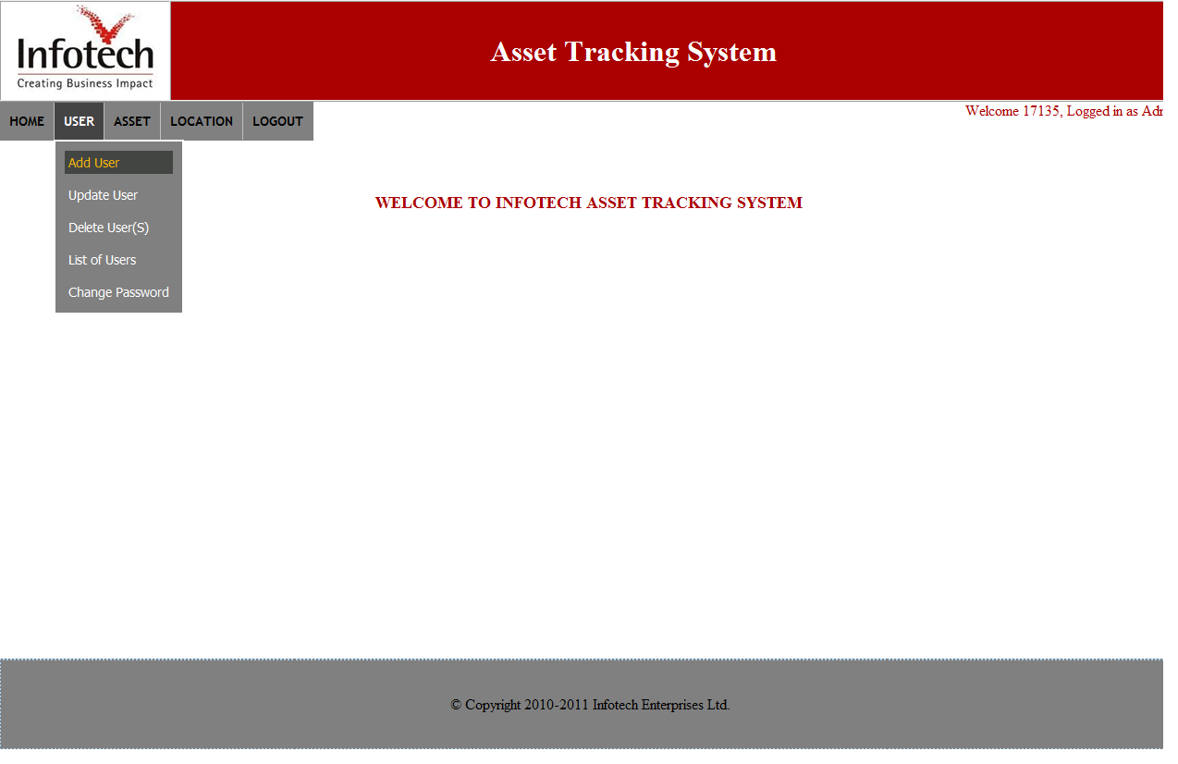

1. Enter the required details in the text boxes and press “submit” to save or “cancel” to go back to home page.

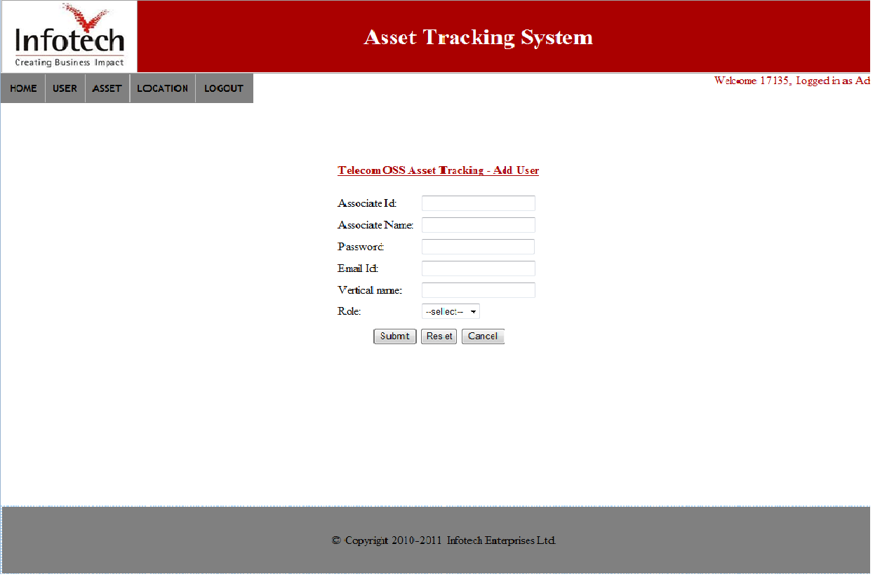

## Update User:

Updating user deals with modifying or editing the values that is already set by the administrator or user. Updating the details of a user can be done by administrator only. This functionality is of very much importance as it enables a user to modify his erroneous details or make any changes to the assets he owns.

The following screenshots shows the actual usage of this functionality:

1. Place the cursor on user menu and select update user option.

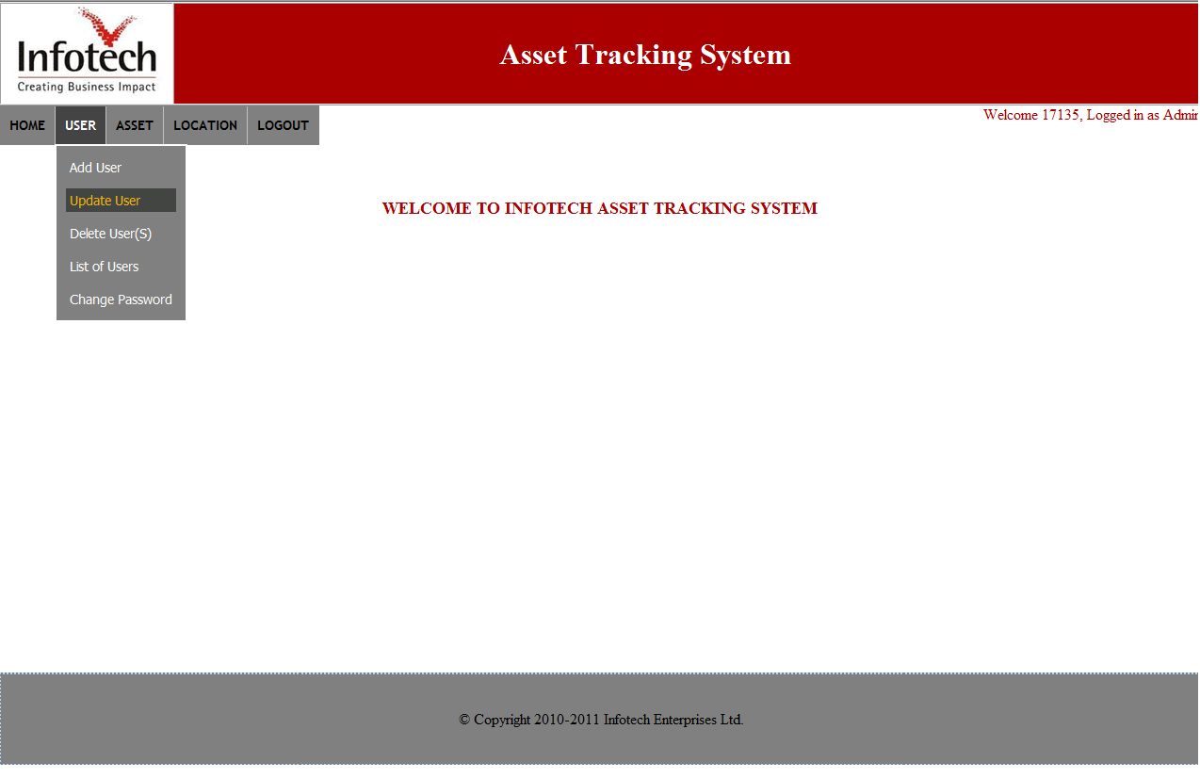

1. Select the intended associate id and the select the role which he needs to be swapped and press on submit to update the role of the user.

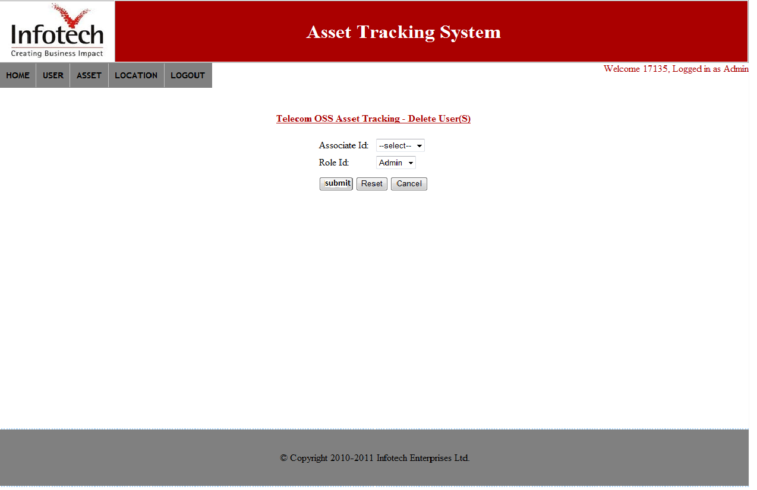

## Delete users:

Whenever a person quits an organisation or leaves a team, then that person must be deleted or removed from the list of users of that team. So for that purpose delete user functionality has been introduced and the privileges for using this functionality have been assigned to administrator only. The assets of the deleted user will be stored in a pool of data and will be assigned back to a new user by administrator.

The following screenshots demonstrates how to delete a user from the inventory:

1. Place the cursor on user menu and select delete user(s) option.
2. Select a user or multiple users and press delete button to delete the users or cancel to go back.
3. When the administrator press delete button then a confirmation box will be prompted and upon cancelling that the assets of that particular user will be stored in a pool of data.

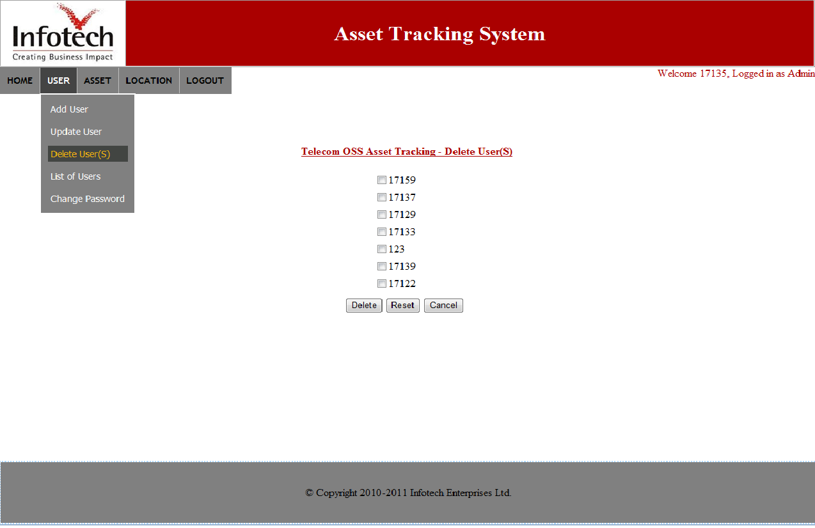

## Change Password:

It is recommended for the users to change their passwords frequently. The reason to change your password is that the longer your password remains the same, the more likely it will be discovered by a malicious user. Change password functionality allows the user to change his password at any time.

The usage of this functionality is demonstrated in the following way:

1. Place the cursor on user menu and select change password option.
2. Enter the current password first and the new password in the corresponding fields.
3. New password entered should match with confirm password or the system will throw an alert.

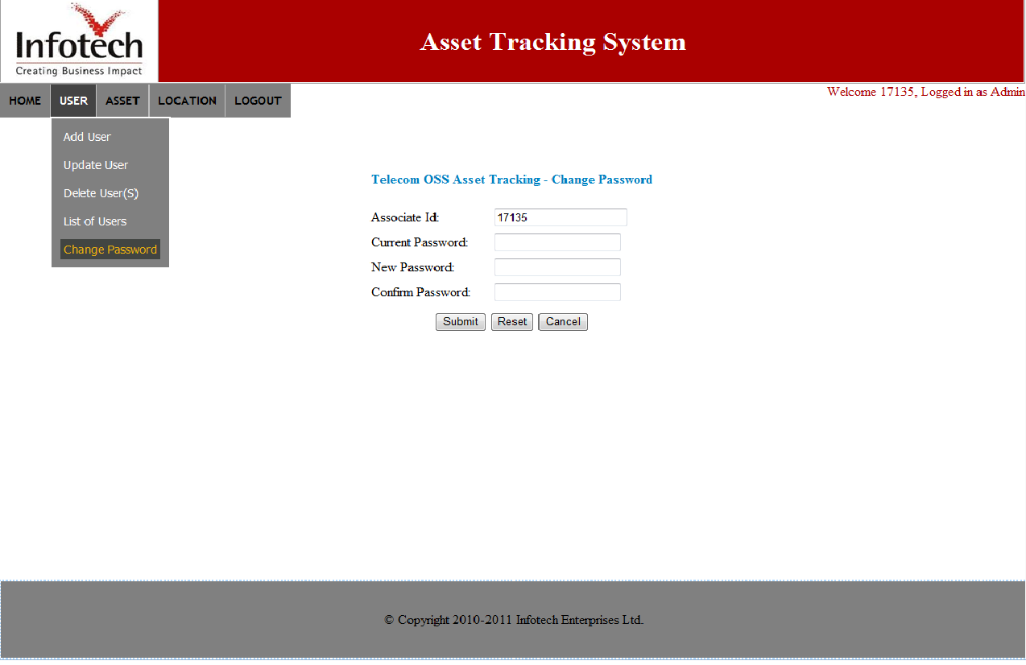

## List of Users

An administrator before adding a user has to be aware of existing list of users in the system. So for that purpose list of users has been added to the application.

The usage of this functionality is explained in the following screenshot:

1. Place the cursor on user menu and select change password option.
2. The list of users will be displayed and press cancel to go back to home page.

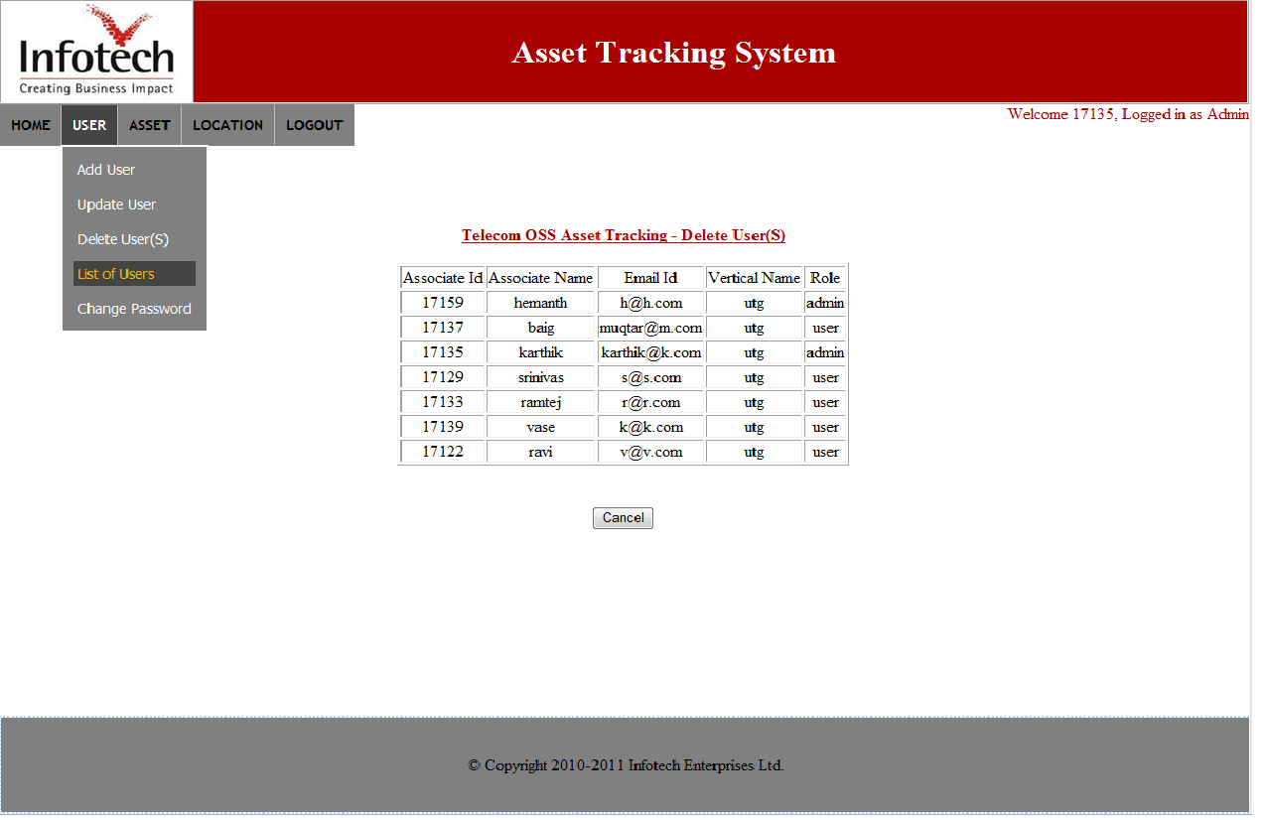

# – Asset Management

Detailed

## Add Asset:

The primary role of an administrator is to create user, after adding a user he needs to add some assets to that particular user though it’s not mandatory. So for the purpose of adding assets to a user this functionality has been added. Even a normal user can add assets but only to his profile.

The detail demonstration of this functionality is as follows:

1. Place the cursor on ASSET menu and select add asset option.
2. After filling the complete details in the fields press submit button to save or cancel to go back to home page.

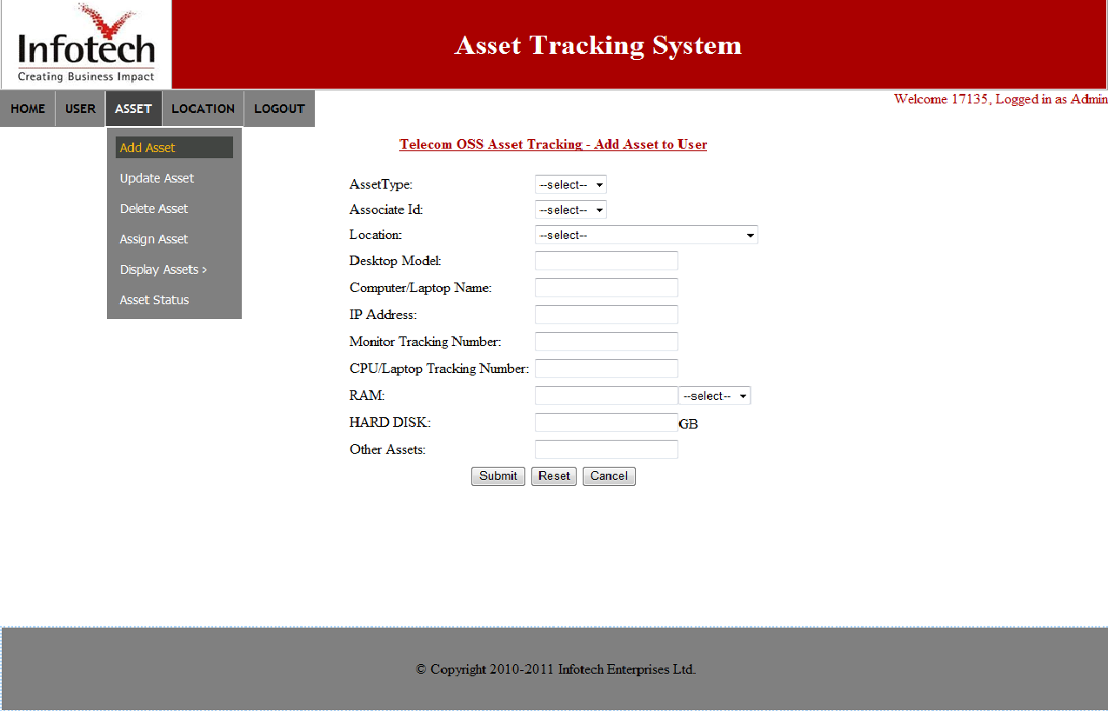

## Update Asset:

Whenever a user or admin adds an asset to the inventory it is sometimes possible that he saves an erroneous data or even sometimes there might be a situation where the existing details needs to be modified or some extra assets needs to be added. So in that case user can use this update asset option to edit and update the existing data.

The update asset functionality is demonstrated as follows:

1. Place the cursor on ASSET menu and select update asset option.

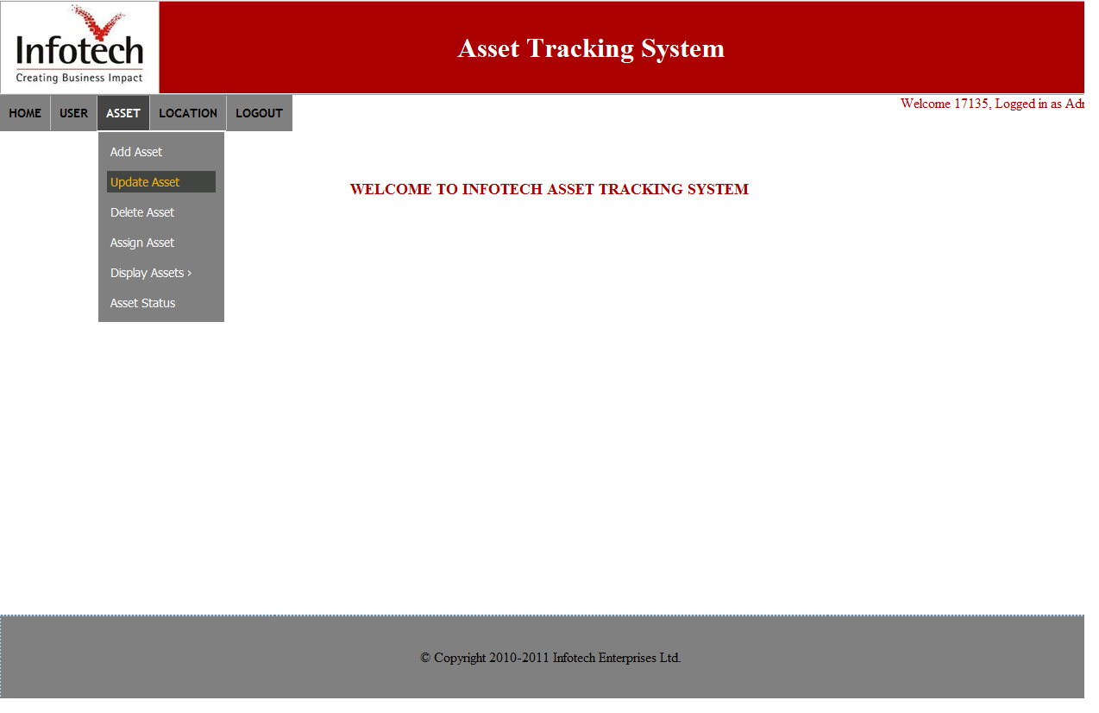

## Delete Asset:

The assets of some users will sometimes be de-allocated or removed and some new assets will be assigned to them. In that situation it is the responsibility of administrator to delete the existing assets of the user. It can be done by using delete user option under asset management menu. Here the administrator has the option to view the asset details before deleting them from the inventory.

The following shows the full demonstration of this functionality:

1. Place the cursor on ASSET menu and select Delete asset option.

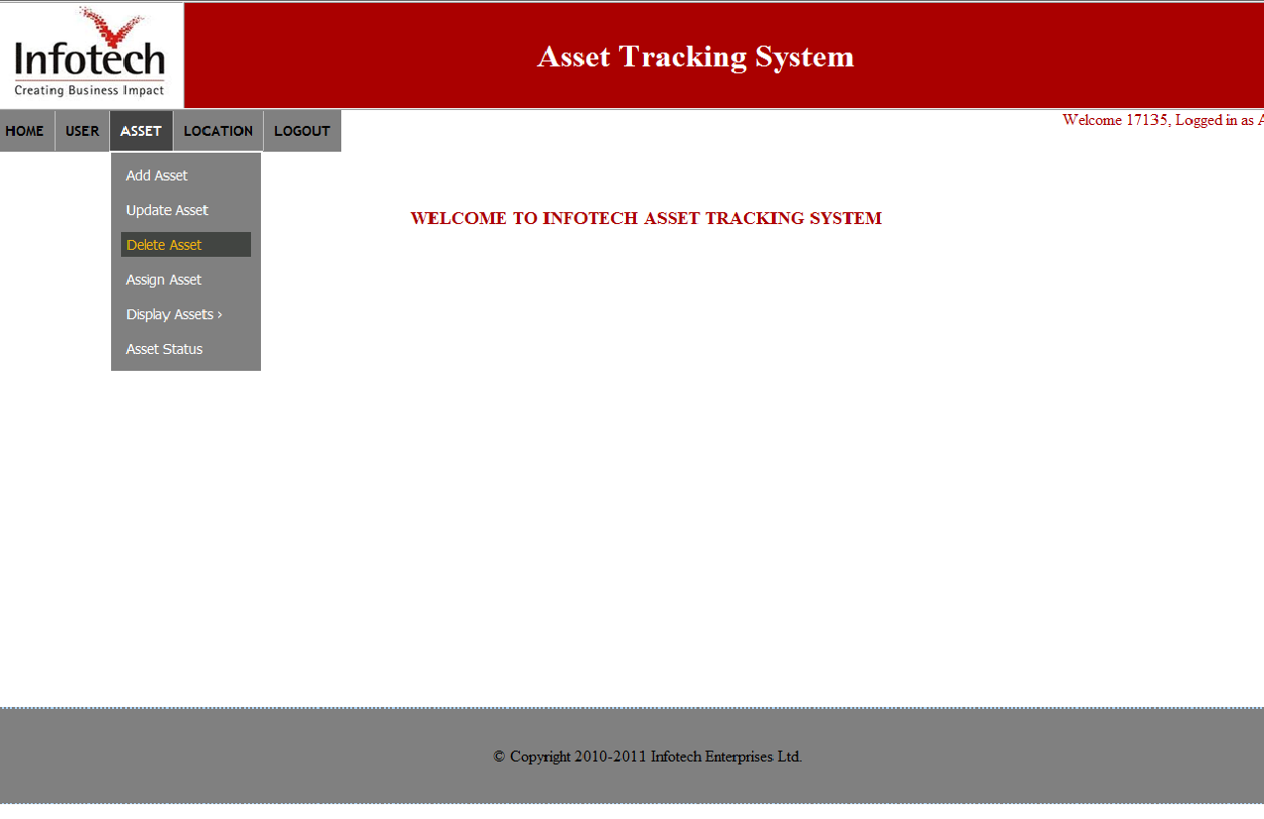

## Assign Asset:

Whenever a user has to be removed from the organization or moved to other team, he should be deleted from the asset tracking of the current team. So when the user is deleted his assets are set to unassigned status and stored in a pool. Now, when a new user is added to that team instead of assigning new assets to him administrator can assign the existing assets from the pool of unassigned assets. This can be done using assign asset tab. Admin can not only assign assets to new users but also assign them to existing users as well.

The following screenshots guides you through the series of activities to be followed for using this functionality:

1. Place the cursor on ASSET menu and select Delete asset option.

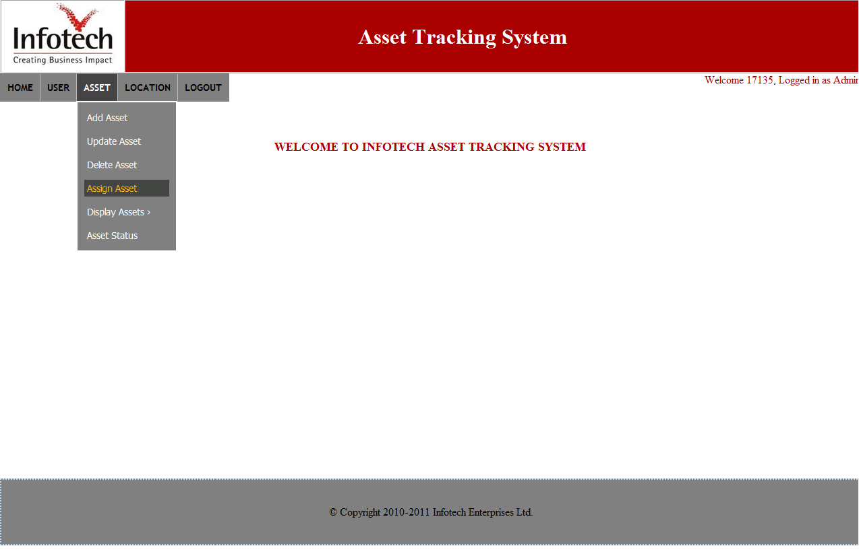

## Display Assets:

This functionality allows all kinds of users to view all kinds of assets and the user to which they have been assigned. It again has three kinds of selections to be made. They are:

### Desktop:

In order to view the details related to only asset type “desktop” this tab has to be selected and the following procedure explains you about this selection:

### Laptop:

To view all the laptop related details this selection has to be made and the following screenshots explains its usage:

### All:

For viewing details of both desktop and laptop in one place “all” tab has to be selected. It can be done in the following way:

1. Place the cursor on ASSET menu and select Display asset option.
2. Depending on the asset type you want to view select the corresponding link.

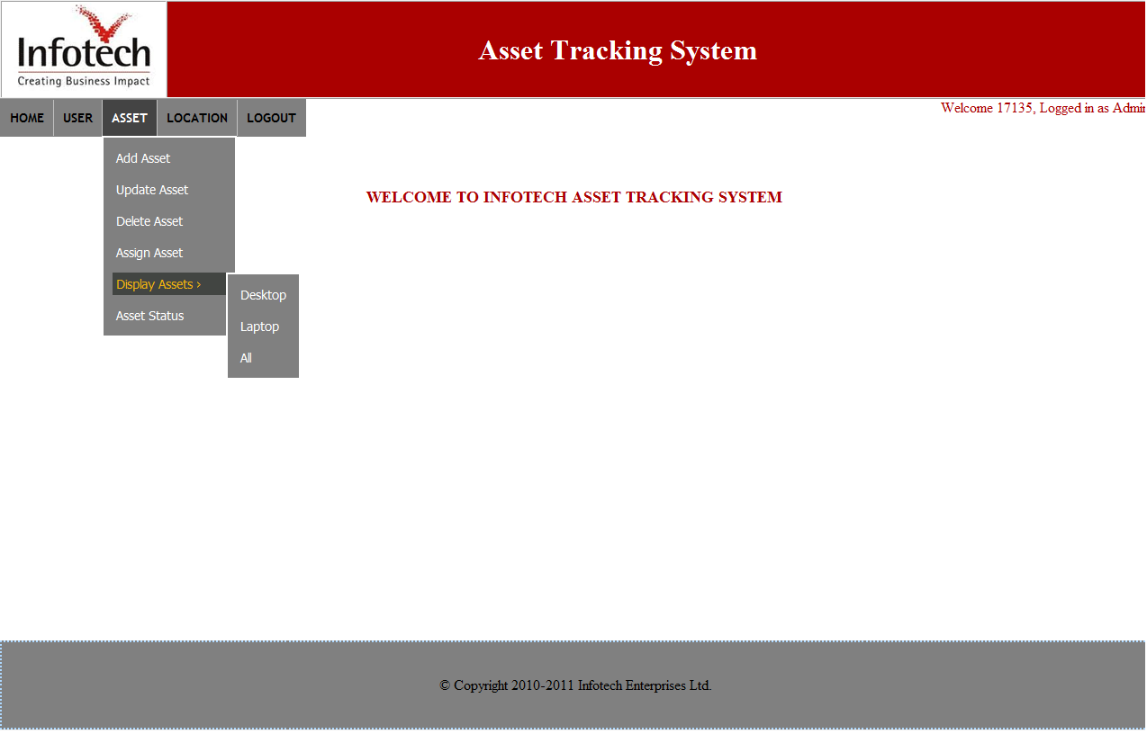

**SELECTION OF “DESKTOP”:**

The below screenshot will appear if the user selects “desktop”. Basic operations like updating and deleting can be done to those details. Even the report generation is enabled in this where the user has to press print button to generate a report.

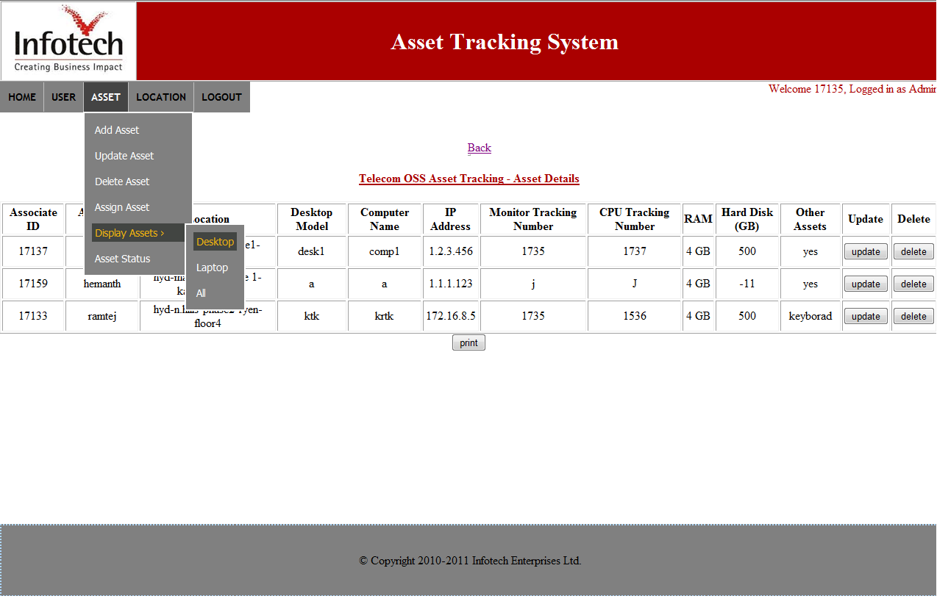

**SELECTION OF “LAPTOP”:**

The following screenshot appears when a user selects “ laptop ” under display assets menu. The same operations which are available in the desktop are available in this as well. In this page asset details related to only the asset type laptop will be displayed.

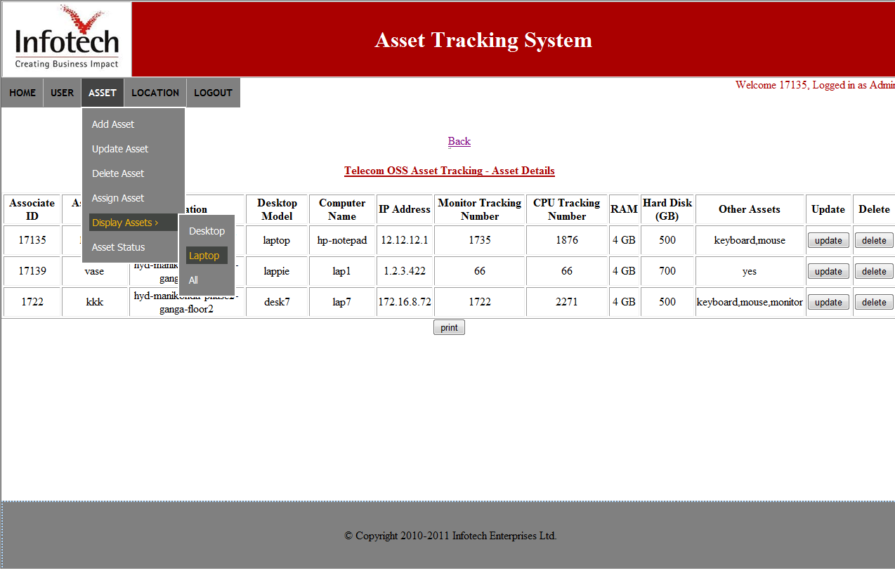

**SELECTION OF “ALL”:**

Upon the selection of “all” by the user under display assets menu the following screenshot appears. It consists of the asset details of all the assets available in the inventory. The operations like updating and deleting the assets have been enabled along with printing of assets.

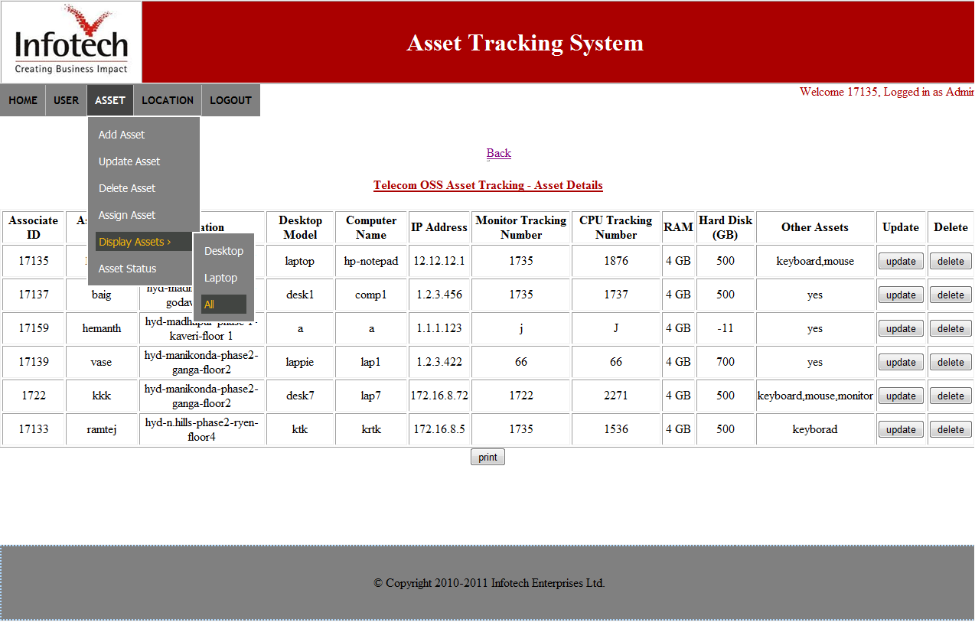

## Asset Status:

The responsibility of the administrator is to assign assets to the new users and can even add some new assets to a user. Before assigning or adding the assets it is recommended for the admin to be aware of already existing assets and their status or else it might lead to one asset being allocated to many people. So in order to get rid of such situation asset status tab has been used where all kinds of users can have a look at the assets and their status.

The following screenshots explains its usage:

1. Place the cursor on ASSET menu and select asset status option.

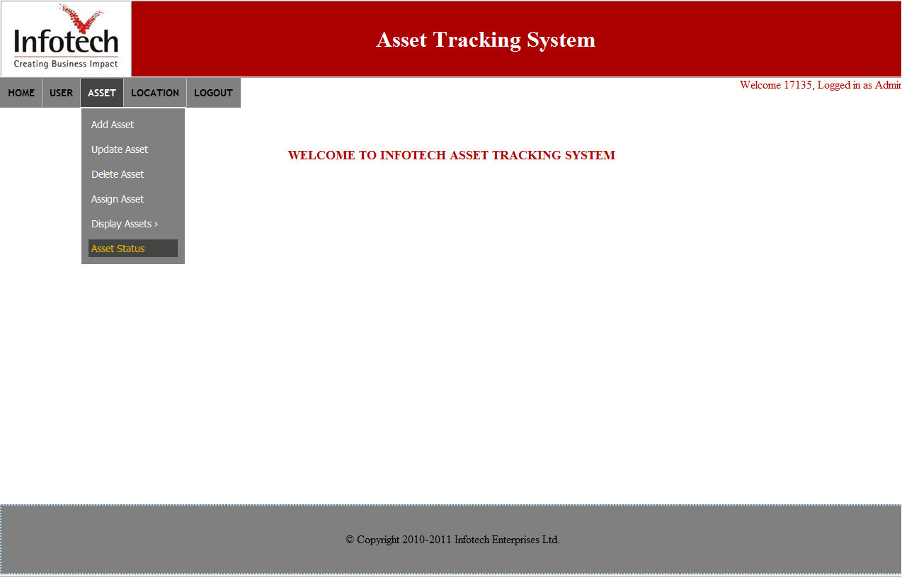

# – Location Management

Location management deals with all the operations pertaining to locations. It typically consists of three operations adding, deleting and displaying locations. Only the administrator has the privileges to perform all these operations. The 3 functionalities and their usages are explained below.

## Add Location:

Whenever a new block or a new location has been added to the organization, then the same has to be reflected in the application. “ADD LOCATION” tab can be used by the administrator to add any new location to the system.

Adding a location to the inventory has been explained in the following screenshots:

1. Place the cursor on location tab and select add location option.
2. Enter the required details and press submit to save them and cancel to go back to home page.

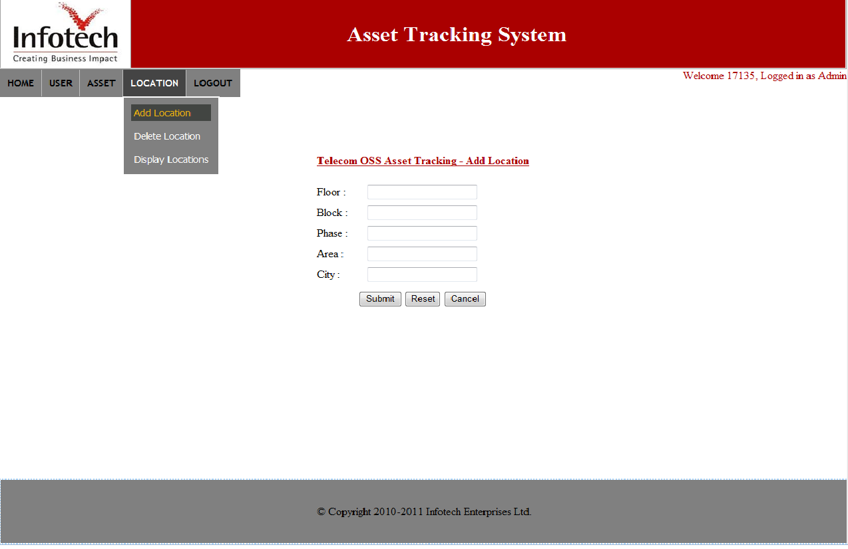

## Delete Location:

If any location is added erroneously to the inventory or In case of deleting any existing location this functionality should be used. The privilege to delete location is given to admin only.

The following screenshots demonstrates the process of deleting location from inventory:

1. Place the cursor on location tab and select add location option.

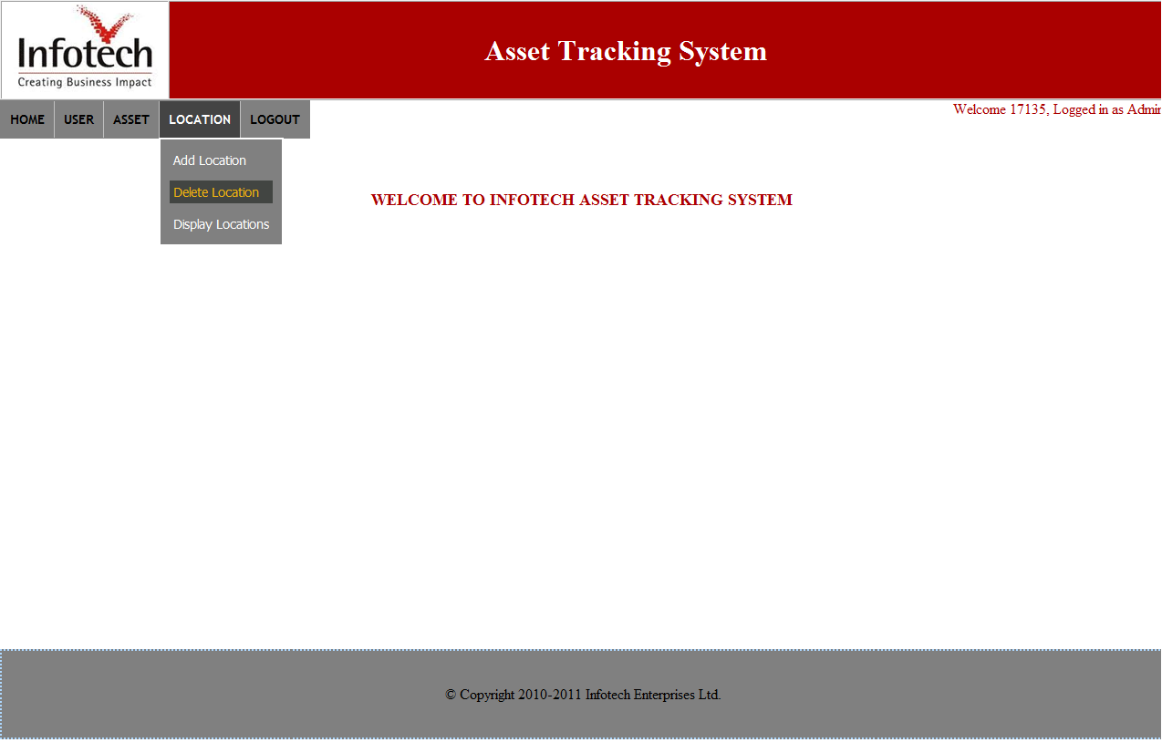

## Display Locations:

List of available locations can be displayed using this tab which can be used by all the users. It is recommended for the administrator to go through the list of locations before adding any new location to the inventory.

The following screenshots explains the process of using this functionality:

1. Place the cursor on location tab and select add location option.

